COS20007-Object Oriented Progamming

Custom Program Documentation

Exploding Kittens

Last update: October 3, 2021

Github Repos: <https://github.com/Jiruu246/Exploding_Kittens.git>

UML (for the latest update please do check out the files in the Documentation folder)

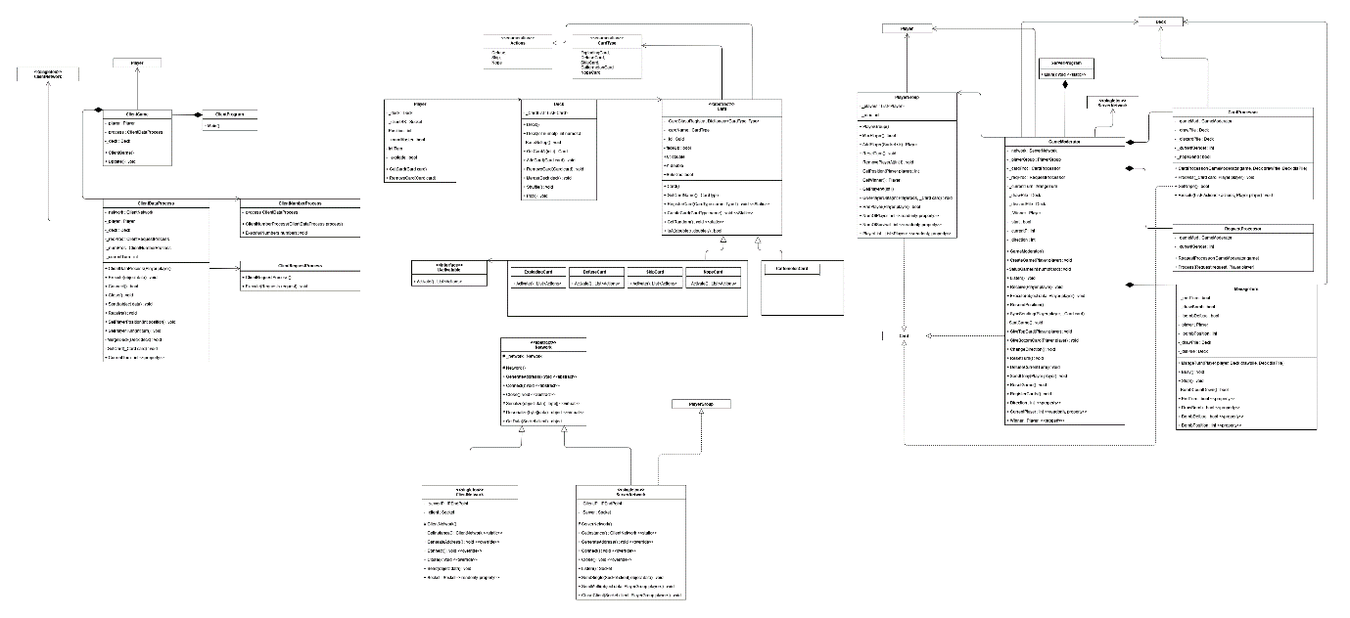

**How it works:**There are two main components: Server and Client, they communicate by sending object data throughout the network. The Server will responsible for creating a player object for each client who connects to it, managing the game based on the game rules, listening for player requests, and tell the player what to do. The Client will be responsible for helping the actual player interact with the game using CLI or GUI. It tells the player what they got or what they need to do and sends the player actions/data to the Server.

**Inheritance and Polymorphism**

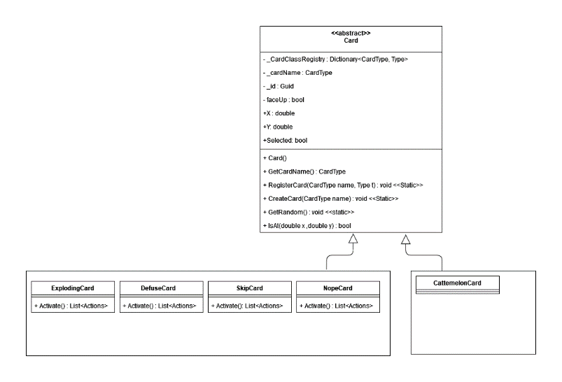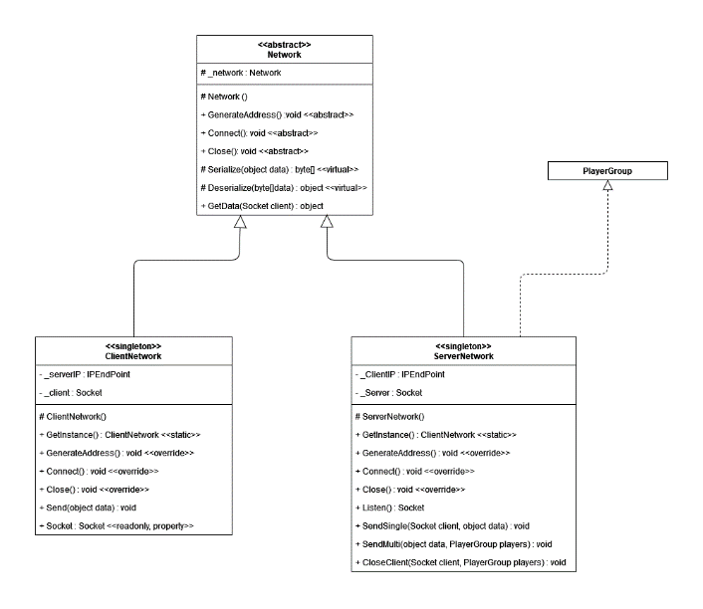

Two significant inheritance is the Network class and Card Class